|  |
| --- |
| Day 14 assignments by lokesh nadella |
|  |

1.research and write what is the use of sealed class and write a c# program to illustrate sealed class??

using System;

using System.Collections.Generic;

using System.Linq;

using System.Text;

using System.Threading.Tasks;

namespace day14_project

{

sealed class Police

{

public static int Helpline = 1000;

public string Getsecret()

{

return "007";

}

}

internal class Program

{

static void Main(string[] args)

{

Police p = new Police();

Console.WriteLine(p.Getsecret());

Console.WriteLine(Police.Helpline);

Console.ReadLine();

}

}

}

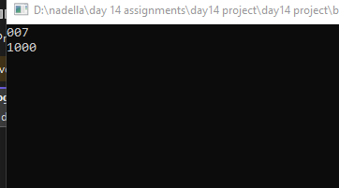

|  |
| --- |
| 2.write a c# program to check if number is prime or not using logic discussed in class?? |

using System;

using System.Collections.Generic;

using System.Linq;

using System.Text;

using System.Threading.Tasks;

namespace day_14_project_2

{

internal class Program

{

static void Main(string[] args)

{

int n = 10, i;

for (i = 2; i < n; i++)

{

if (n % i == 0)

break;

}

if (i == n)

Console.WriteLine("prime number");

else

Console.WriteLine("not a prime number");

Console.ReadLine();

}

}

}

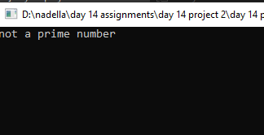

|  |
| --- |
| 3.printing numbers from 1 to 30 and skip numbers divisible by 3 using continue?? |

using System;

using System.Collections.Generic;

using System.Linq;

using System.Text;

using System.Threading.Tasks;

namespace day_14_project3

{

internal class Program

{

static void Main(string[] args)

{

for (int i = 1; i <= 30; i++)

{

if (i % 3 == 0)

continue;

Console.WriteLine(i);

}

Console.ReadLine();

}

}

}

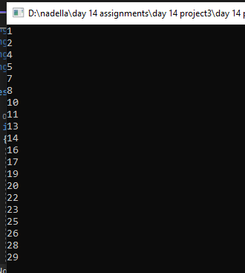

.

|  |
| --- |
| 4.find the first number after 1000 which is divisible by 97 use for loop and break?? |

using System;

using System.Collections.Generic;

using System.Linq;

using System.Text;

using System.Threading.Tasks;

namespace day14_project4

{

internal class Program

{

static void Main(string[] args)

{

for (int i = 1000; i <= 1097; i++)

{

if (i % 97 == 0)

{

Console.WriteLine(i);

break;

}

}

Console.ReadLine();

}

}

}

